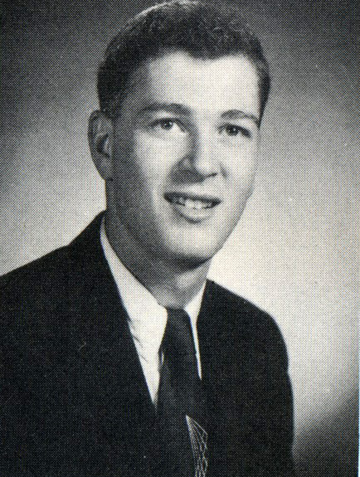
Captain Leonard LaShack 2016 Leonard LaShack 1956

I Joined the RPI Cheerleading squad simply (a) so as to get noticed and grab attention, and (b) because I could do so, having been a gymnast and tumbler in high school. And lacking luscious young pulchritude to lead the cheers, that’s what the all male RPI cheerleading squad did, yell, scream, and do acrobatics!
Quite amazing to me in view of my non-spectacular academic performance as an undergraduate, and having been kicked out of the AF ROTC after two years as unlikely military officer material in the Air Force’s judgment! (I eventually retired from the USN as an O-6 Captain).
What I mostly learned at RPI was “how to learn by myself.” Fortunately, I also learned how to survey. An unlikely skill to learn considering that I started RPI as an Electrical Engineer. After two years at RPI, however, I recognized I wished for an adventurous career in which I could regularly work outdoors. To remain at RPI and also pursue my desire for outdoor adventures, my only RPI curricular choices then would be Geology/Geophysics or Civil Engineering. I chose Geology/Geophysics. That department quickly insisted I take the course in surveying from the Civil Engineering Department. A good thing too, since upon graduation my first serious job--with the US Antarctic Expedition during the 1957-1959 International Geophysical Year (IGY), required me to stake out and survey-in a major grid, on the ice, where I and my colleagues subsequently recorded numerous geophysical measurements to characterize the Ice surface above and the rock basement below.
The logistics for the US Antarctic Program were largely handled by the US Navy. The Commander US Forces Antarctic, a senior Navy Captain who I got to know, recognizing I was still at the mercy of my draft board, observed that he thought I was good Navy officer material and urged me to apply to Navy Officer Candidate School, and that he would recommend me! I did apply, graduated, and was commissioned.
Upon commissioning, my first assignment, as a Navy Ensign, was to Air Force Drifting Ice Station T3 where I was ordered to survey, and orient with respect to True North, an acoustic array beneath the ice to track nuclear submarines! My next assignment was to the Office of Naval Research in Washington, DC, where I learned both to read, evaluate, and write proposals for Government funding, as well as garner funding from oil companies exploring beneath the Arctic Ocean to mathematically describe sea-ice statistics in areas of interest where they wished to explore.
A lifetime of outdoor adventures around the world continued from there. See the Class website for a presentation entitled, “From RPI Cheer-Leader to Cold-War Hero.” That “hero” status was bestowed upon me by both the US Navy and the CIA, all within five years of graduating from RPI.

